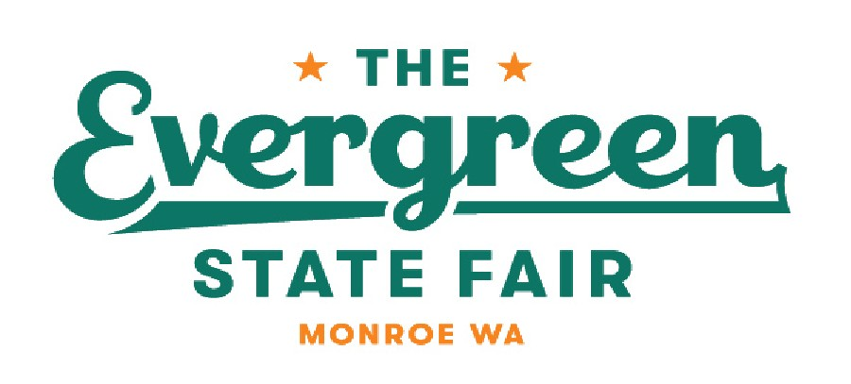

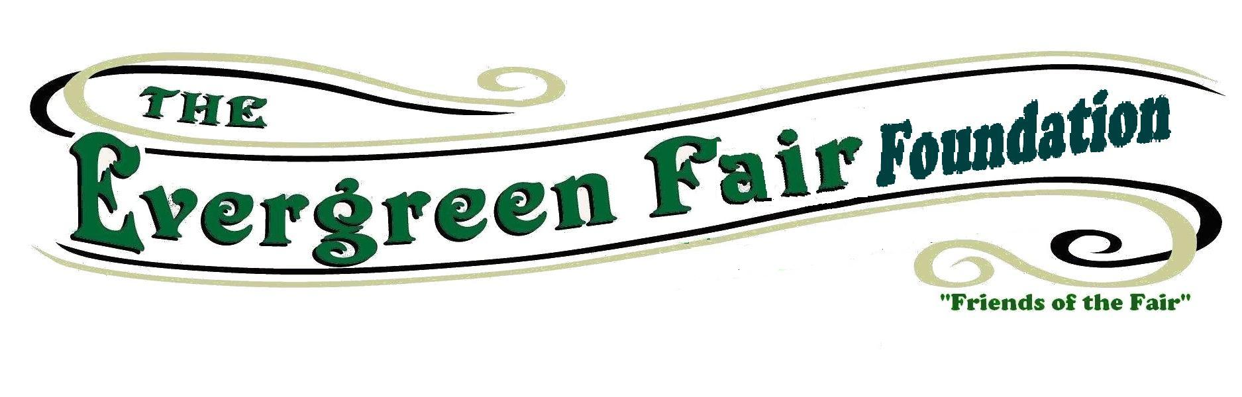

Do you Love the Evergreen State Fair? Would you like to represent our amazing fair?

We are looking for Youth to help represent the Evergreen State Fair. Youth in their Junior year of High School are asked to participate.
Ambassadors must be willing to represent the Fair in activities that promote the Fair and youth participation. Example: Food Drives, Monroe Day and parade activities.
Applicants will be required to present an essay regarding their fair experiences and what the Fair means to you. Applications must be in by January 15th to the Evergreen State Fair Office.
Winners will receive a $500 scholarship to a college or technical school of their choice. The winners will be announced at The Fair Kick off dinner in March.
The Foundation will select two winners per year. Help us celebrate this Great Fair!!

Evergreen State Fair Ambassador Application.

Name:
Address:
Phone:
Email:
Parent Contact information:
Years and Departments exhibiting at Evergreen State Fair:

Please write a 500-word essay about why you would like to be our Fair Ambassador, What the Fair means to you, your experiences and how it has helped you prepare for your future.

Please submit this application by January 31, mail to: Evergreen State Fairgrounds – Att. Sherry Stovner 14405 179th Ave SE Monroe, WA 98272
Or Email to: evergreenfairfoundation@yahoo.com

